|  |  |
| --- | --- |
| Ex. No.: 4 | **Mathematical modelling and simulation of Physical systems in at Least Two Fields.**  **Mechanical and Electrical** |
| Date: |

**Aim**

Mathematical modelling and simulation of physical systems (DC motor) in at least two fields: Mechanical and Electrical system.

**Introduction**

A DC motor can be mathematically modelled as an electrical system and a mechanical system, tied together by relationship between back-emf and speed, and relationship between current and torque. In this experiment, the electrical and mechanical parameters of the DC motor are determined. These values are necessary to design a proper control system to control motor speed, torque, or position as will be seen in later experiments.

**Theoretical background:**

**Motor model**

The DC motor, like all real-world systems, exhibits non-linear behaviour. In the model shown below, a linearized DC motor model is considered for the sake of design simplicity. It will be verified in later experiments that the results from the simulated linearized model closely matches the real-world model thus validating this approximation.

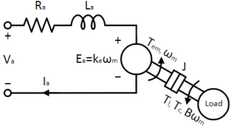

The torque Tem is proportional to the armature current Ia as given in Eqn. 1 where kt is the torque constant.

$T_{em}=k_{t}×I_{a}$----------------------------------------------------------------- ( 1)

As the motor rotates, the armature winding cuts through the magnetic field which induces the back emf, Ea on the armature winding. When the motor rotates faster, the rate of change of magnetic flux dϕ/dt increases, proportional to the rotor speed. This is given by Eqn. 2 where ωm is the motor speed and ke is the back-emf constant.

----------------------------------------------------------------- ( 2)

Ra and La in the above model refer to the armature resistance and inductance respectively. The voltage applied at the terminal Va equals the sum of voltage across the passive element - Ra and the back-emf Ea. This represents the electrical model of the DC motor and is given in Eqn. 3, where Ea has been replaced with ke × ωm from Eqn. 2.

-----------------------------------------------------------------( 3)

The mechanical model of the DC motor is given in Eqn. 4. Under steady state, the torque generated by the motor Tem equals the sum of load torque Tl and the torque necessary to compensate the frictional losses, Tfric. In transient condition when Tem ≠ Tl + Tfric, the motor accelerates if the former is greater than the latter, storing the excess energy as inertial energy. It decelerates if the former is less than the latter, loosing previously stored inertial energy. The motor inertia is identified as J in Eqn. 4.

Tem = Tl + Tfric + Jdωmdt------------------------------------------------ (4)

The frictional component is due to various factors and is always against the direction of rotation. o The torque Tem is proportional to the armature current Ia as given in Eqn. 1 where kt is the torque constant.

$T_{em}=k_{t}×I_{a}$*----------------------------------------------------------------- ( 1)*

As the motor rotates, the armature winding cuts through the magnetic field which induces the back emf, Ea on the armature winding. When the motor rotates faster, the rate of change of magnetic flux dϕ/dt increases, proportional to the rotor speed. This is given by Eqn. 2 where ωm is the motor speed and ke is the back-emf constant.

*----------------------------------------------------------------- ( 2)*

Ra and La in the above model refer to the armature resistance and inductance respectively. The voltage applied at the terminal Va equals the sum of voltage across the passive element - Ra and the back-emf Ea. This represents the electrical model of the DC motor and is given in Eqn. 3, where Ea has been replaced with ke × ωm from Eqn. 2.

*-----------------------------------------------------------------( 3)*

The mechanical model of the DC motor is given in Eqn. 4. Under steady state, the torque generated by the motor Tem equals the sum of load torque Tl and the torque necessary to compensate the frictional losses, Tfric. In transient condition when Tem ≠ Tl + Tfric, the motor accelerates if the former is greater than the latter, storing the excess energy as inertial energy. It decelerates if the former is less than the latter, loosing previously stored inertial energy. The motor inertia is identified as J in Eqn. 4.

Tem = Tl + Tfric + Jdωmdt------------------------------------------------ (4)

The frictional component is due to various factors and is always against the direction of rotation. of the many causes, only Coulomb friction which is a constant and viscous friction which varies proportionately with rotational speed are considered, since these are the ones that have significant effect on the steady-state. The torque associated with Coulomb friction is given by Tc and that of viscous friction is given by B × ωm, where B is the coefficient of viscous friction. Substituting these into Eqn. 4 yields the final mechanical model as given in Eqn. 5.

Tem = Tl + Bωm + Jdωmdt------------------------------------------------ (5)

**Parameter estimation**

In this experiment, the electrical model parameters, Ra, La, ke, kt and, the mechanical model parameters, B and J, are determined for the DC motor as follows:

**Ra:** Use a Multimeter and measure resistance of armature winding.

**La**: – Use LCR meter measure inductance of armature winding

**ke** Apply a constant voltage Vo at the motor terminal. Measure the motor current Ia and motor speed ωm at steady-state. Compute ke from Eqn. 6, which is obtained from Eqn. 3 .

**ke**: = (Va – RaIa)/ωm------------------------------------------------ (6)

**kt:** Calculate kt from name plate details

Note the rated output power P, Rated speed N in radian/sec and rated current Ia

By using the above calculated the rated torque

T = 60*P/(2*π*N) ------------------------------------------------ (7)

Calculate kt using Eqn. 1

kt = T/Ia------------------------------------------------ (8)

**B:** If the motor is not accelerating i.e. motor speed is a constant, and there is no load connected, the inertial torque component and load torque component in Eqn. 5 becomes zero, leading to the following equation:

Tem = Bωm(11) ------------------------------------------------ (9)

Apply a constant voltage V, at the motor terminal. Measure the motor speed ωm, and current Ia. The electromagnetic torque Tem can be computed from the measured current Ia using Eqn. 1. Repeat the same for different voltages and plot the result, Tem (y-axis) vs. ωm (x-axis). The resulting plot will be linear. The slope of the plot equals the coefficient of viscous friction B.

**J:** Apply a constant voltage V, at the motor terminal. Once the speed settles down, measure the speed ωm, and motor current Ia. At steady state, the electromagnetic torque Tem (Eqn. 1), solely compensates for drag due to friction. Disable the inverter so that the motor current dies-down to zero rapidly. After this, there is no electromagnetic torque and all the frictional losses must be supplied from the inertial energy. This leads to the motor to stop gradually. This is summarized in Eqn. 10, which is obtained by equating Tem and load torque Tl in Eqn. 4 to zero.

0 = Tfric + Jdωm/dt------------------------------------------------ (10)

At the moment the inverter is disabled, time t = Tdis, the frictional torque component Tfric is same as, that of electromagnetic Tem just before disabling the inverter, which can be obtained from the steady-state current Ia before disabling the inverter using Eqn. 1. Substituting this into Eqn. 10 yields:

J = ke×Ia(Tdis)/ dωm/dt(Tdis) ------------------------------------------------ (11)

Thus, the motor inertia can be obtained by dividing, the electromagnetic torque just before disabling the inverter, with the motor deceleration just after disabling the inverter.

**Procedure:**

Step 1: Derive differential equation for the DC motor.

Step 2: Add the respective blocks in MATLAB – simulink for the derived transfer function.

Step 3: By applying the rated speed and note the value of resistance, inductance, current.

Step 4: Calculate the value of inertia (J) and friction (B)

Step 5: Use the calculated value for the simulation and analyse the graph.

**MATLAB Circuit:**

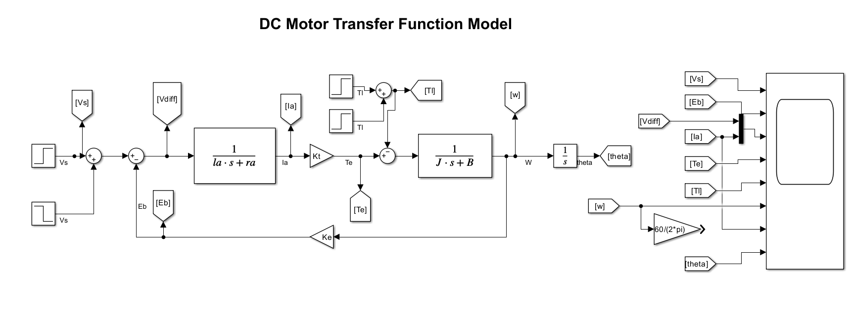

**Output Waveform**

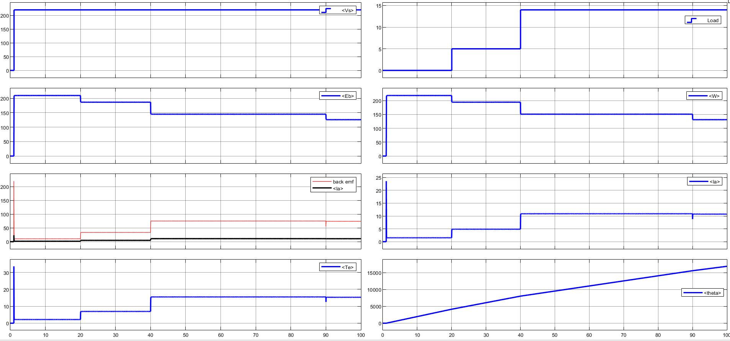

**Inference**

**Result**

Thus, mathematical modelling and simulation of physical systems (DC motor) of mechanical and electrical systems is studied.